**GENERAL INTEGRATED SCIENCE– UNIT 2**

**TASK 8 – Atoms, Periodic Table & Chemical Reactions Test**

**NAME: _____________________________________ WEIGHTING: 5%**

**DATE: _______________________________________ MARK: ______ /47 =**

**Multiple Choice Section [12 marks]**

1. A substance that is made up of only one type of atom is called:

a. an element

b. a compound

c. a molecule

d. a mixture

1. The compound C4H12O6  contains:
2. calcium, hydrogen and oxygen
3. calcium, helium and oxygen
4. carbon, helium and oxygen
5. carbon, hydrogen and oxygen
6. The graph below shows the time for which different numbers of candles will burn after being placed in an airtight container.

**Time candles burn in a sealed container**

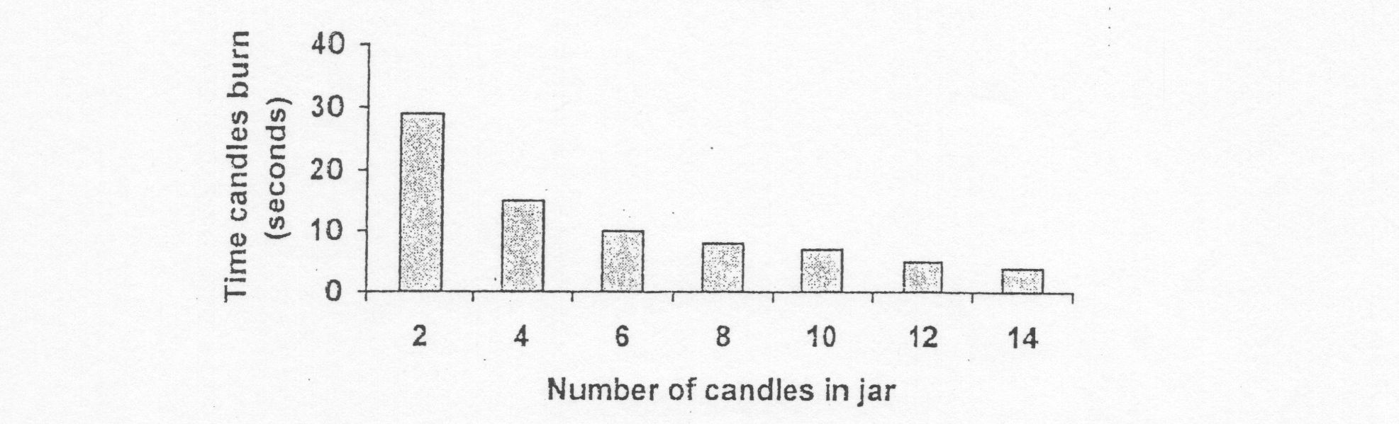

The graph can be used to predict burning times for other numbers of candles in the same jar. For what length of time do you think three candles could burn inside the jar?

1. About 5 seconds
2. About 20 seconds
3. About 10 seconds
4. About 60 seconds
5. In which of the following groups have all the elements been given their correct symbols?

|  |  |  |  |  |  |  |
| --- | --- | --- | --- | --- | --- | --- |
| **Group** | **Silver** | **Lead** | **Calcium** | **Oxygen** | **Hydrogen** | **Carbon** |
| a. | Ag | Pb | Ca | O | H | C |
| b. | Au | Fe | C | O | He | C |
| c. | S | Le | Cu | O | H | Ca |
| d. | Si | Pb | Ca | O | H | C |

1. If iron filings and sulphur were combined by heating to form iron sulphide, the:
2. the iron filings could no longer be separated from the sulphur by using a magnet
3. the particles of sulphur could still be seen with the aid of a hand lens
4. the iron and the sulphur could be separated again by cooling the iron sulphide
5. the iron and sulphur could be separated again by dissolving the sulphur and leaving the iron behind.
6. If pure baking soda is a compound, then it is certain that baking soda:
7. contains some oxygen combined with other elements
8. contains more than one element
9. could be physically broken down into simpler substances
10. is a simple mixture of elements
11. The group below that contains only chemical elements is:
12. carbon, water, oxygen
13. zinc, hydrogen, carbon.
14. water, iron, salt
15. sugar, sulphur, salt
16. If a metal is described as ductile it means that the metal:
17. is hard
18. can be rolled into thin sheets
19. can be drawn out into wires
20. conducts electricity well
21. Water is classed as a compound and not an element because it:
22. is a pure substance
23. is a mixture of elements
24. can be changed into a solid or a gas
25. is formed by the chemical combination of hydrogen and oxygen
26. The compound hydrogen sulphate contains the elements hydrogen, sulphur and oxygen. In any pure sample of hydrogen sulphate there are:

**A:** twice as many atoms of hydrogen as there are of sulphur

**B:** twice as many atoms of oxygen as there are of hydrogen

Which of the following is the formula for hydrogen sulphate?

1. H4S2O
2. H4SO2
3. H2S2O2
4. H2SO4
5. Consider the following table listing the properties of some elements.

|  |  |
| --- | --- |
| SUBSTANCE | PROPERTIES |
| 1 | Shiny, insulator, hard, odourless, brittle |
| 2 | Conducts electricity, shinny, yellow |
| 3 | Low density, shiny, can be beaten into thin sheets |
| 4 | Doesn’t conduct electricity, shiny, melts at 4000 degrees Celsius |
| 5 | Dull, melts at 300 degrees Celsius, brittle |

Based on these observations which of these are metals?

1. 2 only
2. 5 only
3. 2 and 3
4. 1 and 2
5. 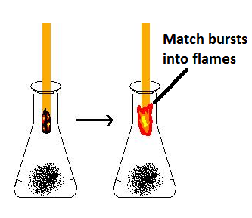Sally’s teacher showed the class a jar which contained a “mystery gas”. Sally tried the following test to see what the gas was; she placed a glowing match into the jar of gas and noticed that it burst into flame.

Sally’s test showed that the mystery gas was probably:

1. oxygen
2. carbon dioxide
3. nitrogen
4. helium

**Short Answer Section *[35 marks]***

* 1. Atoms are comprised of three subatomic particles. List them below: *(1 mark)*

_______________________________________________________________________________

* 1. In the space below, draw the atomic structure of:

*(8 marks)*

|  |  |
| --- | --- |
| **Carbon** | **Sodium** |
| **Hydrogen** | **Neon** |

* 1. The formula for carbon dioxide is CO2. Explain what the “2” means. *(1 mark)*

_______________________________________________________________________________

_______________________________________________________________________________

* 1. List two physical properties of metals. *(2 marks)*

______________________________________________________________________________________________________________________________________________________________

1. 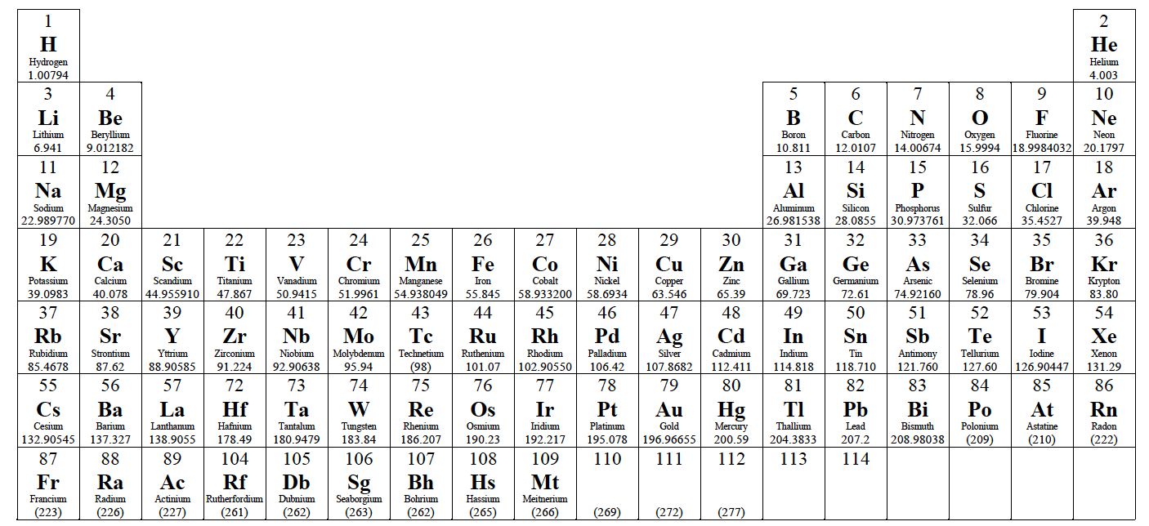The following questions refer to the periodic table below.
   1. What is the name for Group 2? *(1 mark)*

___________________________________________________________________________

* 1. Describe two reasons as to why Francium (Fr) is more reactive than Helium (He). (*2 marks)*

______________________________________________________________________________________________________________________________________________________

______________________________________________________________________________________________________________________________________________________

* 1. On the periodic table above, circle an element that has 6 valence electrons. *(1 mark)*
  2. On the periodic table above, shade in two elements that are gases at room temperature

*(1 mark)*

1. Name all of the elements found in the following compounds:
   1. CuSO4 *(1 mark)*

______________________________________________________________________________________________________________________________________________________

* 1. HNO3 *(1 mark)*

______________________________________________________________________________________________________________________________________________________

1. How many atoms are present in:
   1. C6H12O6 *(1 mark)*

______________________________________________________________________________________________________________________________________________________

* 1. HCl*(1 mark)*

______________________________________________________________________________________________________________________________________________________

1. Describe the difference between an element and a compound  *(2 marks)*

__________________________________________________________________________________________________________________________________________________________________

_________________________________________________________________________________

1. Explain why compounds are considered pure substances. *(1 mark)*

__________________________________________________________________________________________________________________________________________________________________

_________________________________________________________________________________

1. Elements, compounds and mixtures have different physical and chemical properties, which determine the uses of substances. Explain why aluminium would not be an appropriate metal to build a rocket out of.  *(2 marks)*

__________________________________________________________________________________________________________________________________________________________________

_________________________________________________________________________________

1. 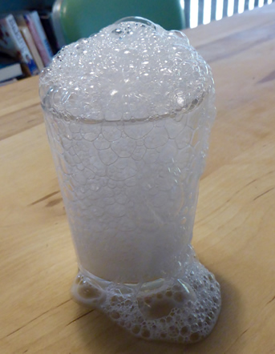A student mixes baking soda and vinegar in a glass. The results are shown below.
   1. Describe how you can tell that a new substance was formed when the vinegar and baking soda were mixed *(1 mark)*

_____________________________________________________________________________

______________________________________________________________________________

* 1. Suppose this reaction was carried out in a cup on top of a scale. Explain whether you think the mass would change as the reaction proceeded. *(2 marks)*

_____________________________________________________________________________

______________________________________________________________________________

* 1. Explain what would happen to the mass if the reaction took place inside a sealed bag instead? *(2 marks)*

_____________________________________________________________________________

______________________________________________________________________________

1. Suzie is fascinated by chemical reactions. She decides to add a small piece of sodium to a bucket of water in order to see if a chemical reaction occurs.

Describe four ways, not including the way listed in question 11a, that Suzie could identify if a chemical reaction has occurred. *(4 marks)*

__________________________________________________________________________________________________________________________________________________________________

_________________________________________________________________________________

__________________________________________________________________________________________________________________________________________________________________

_________________________________________________________________________________

_________________________________________________________________________________